# Instructions for using the AudioLooper

The AudioLooper application can play four different simultaneous sources at one time, mixing their audio and record them as well. The application creates an initial file for each channel in a subdirectory off the directory with the executable. The subdirectory Samples located right off the directory that houses the executable will have up to eight files, Looper_(0-3).wav and Looper_(0-3)_rvrsd.wav. The first four files are the normally recorded files, one for each of the four channels and the last four are reversed versions of the first four.

The application looks as Figure 1. Functionality will be described on a control by control basis, so the user may do what they want without feeling constrained by the author’s ideas of operation.

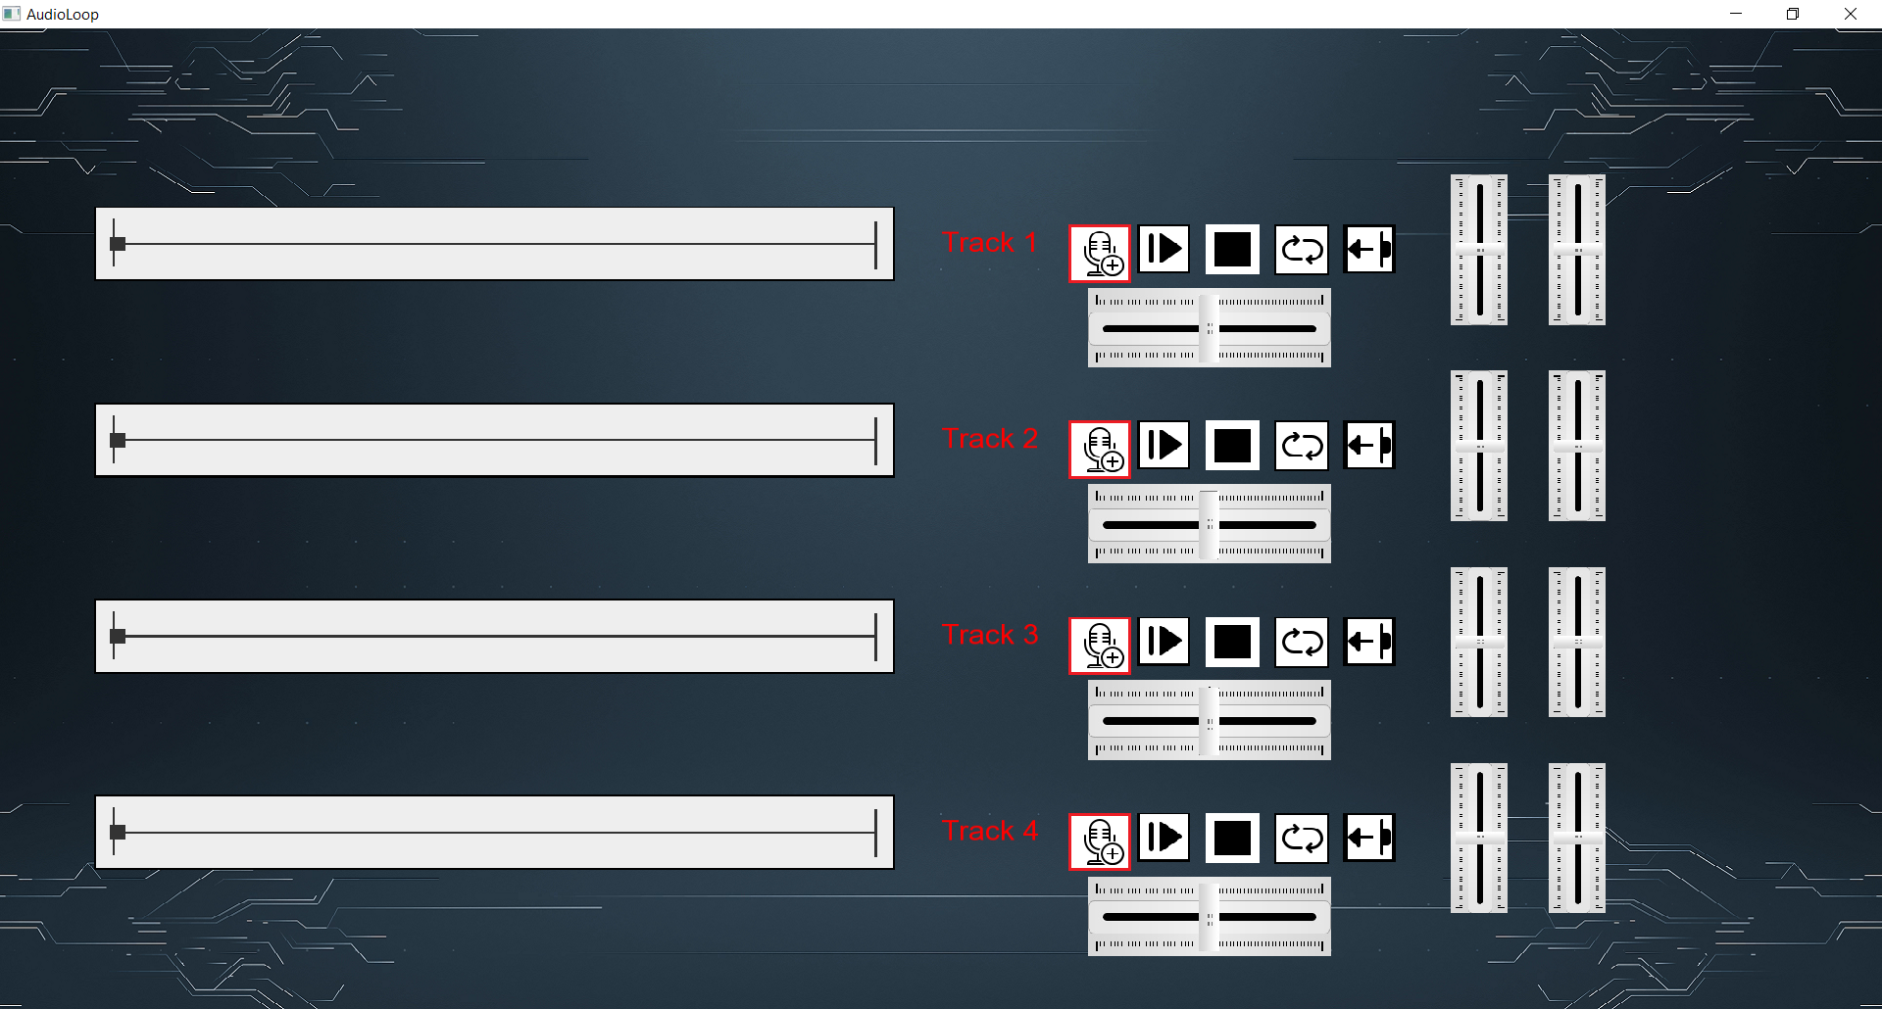

**Figure 1 – the base application**

## Play/Pause Button and MusicSeek bar:

The play button allows the playing of the channel. It is circled in Figure 2. Selecting the circled in blue button will start playing of the current channel’s track. Selecting the button again will cause the playing to be paused. While the track is playing the music bar will move from left to right. The music bar is circled in Figure 3.

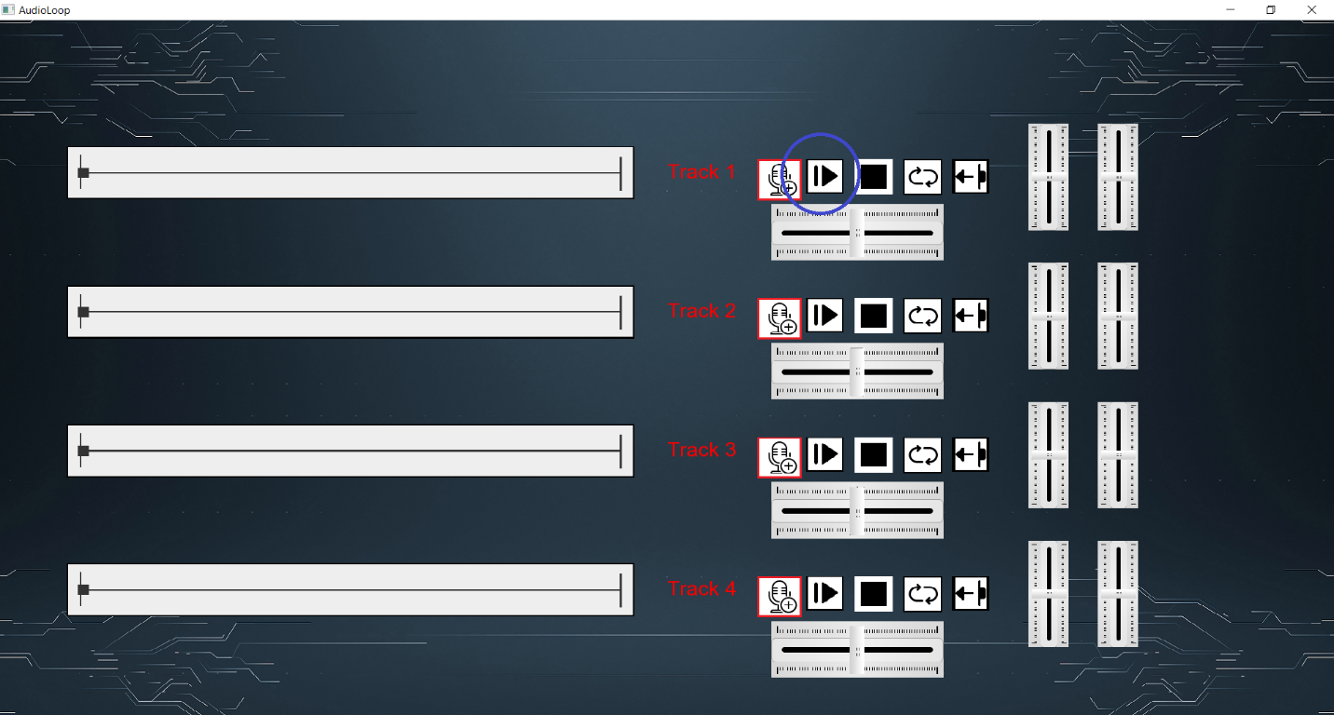

**Figure 2 – The play/pause button**

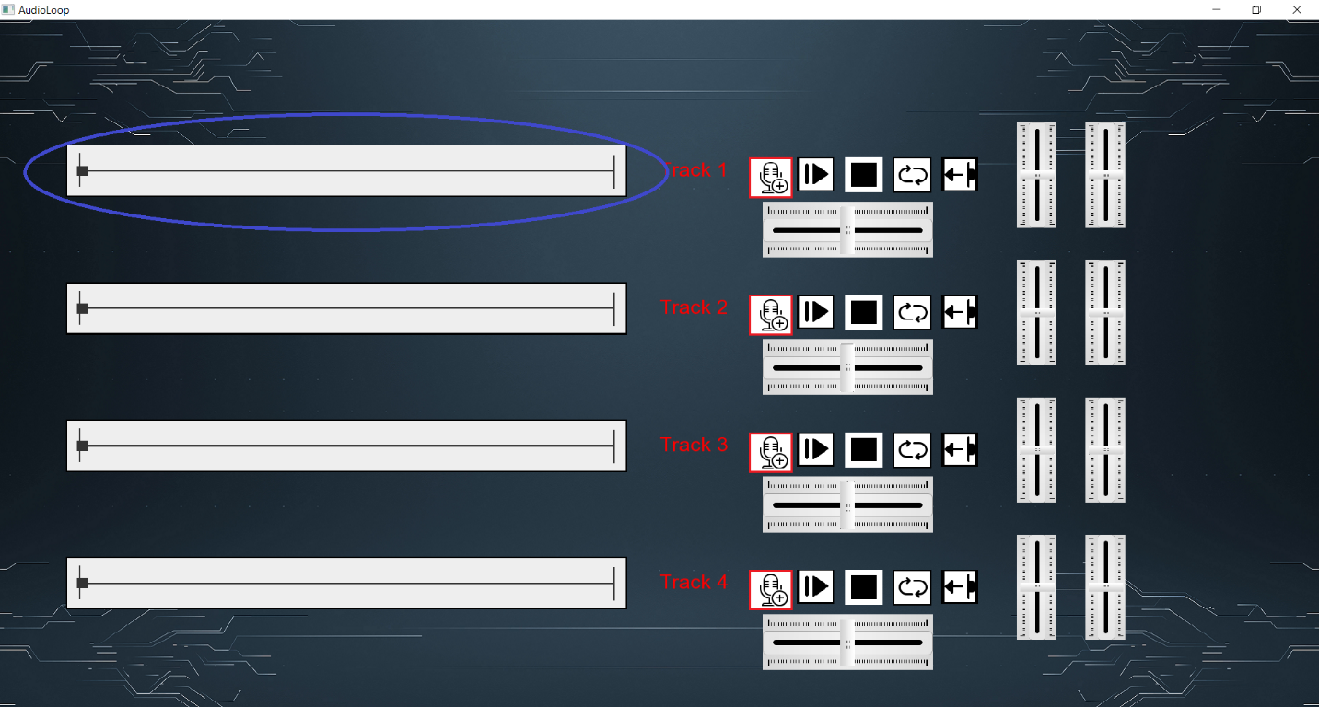

**Figure 3 – The Music Seek bar**

## Stop Button:

When playing or recording, the stop button as circled in Figure 4 may be used to end that task. If playing the track will go back to the beginning when the stop button is pressed. If recording, the file will be closed out and the recording will stop. It provides no other functionality.

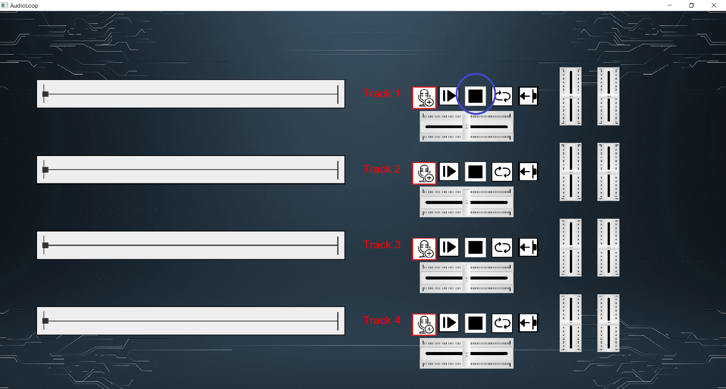

**Figure 4 – The Stop Button**

## Loop Button:

The loop/repeat button may only be used while playing. When selected the loop button will allow the track to continuously loop and repeat until the stop button is pushed or the loop button is selected again. The Music Seek bar will restart and track the progress of the track being played.

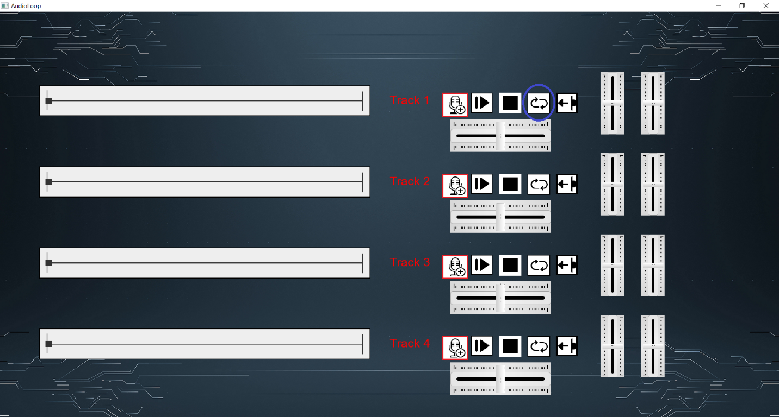

**Figure 5 – The Repeat/Loop button circled**

## Reverse Button:

The reverse button should create a reversed version of the audio file, then play it. It should cause a momentary pause then play the reversed audio.

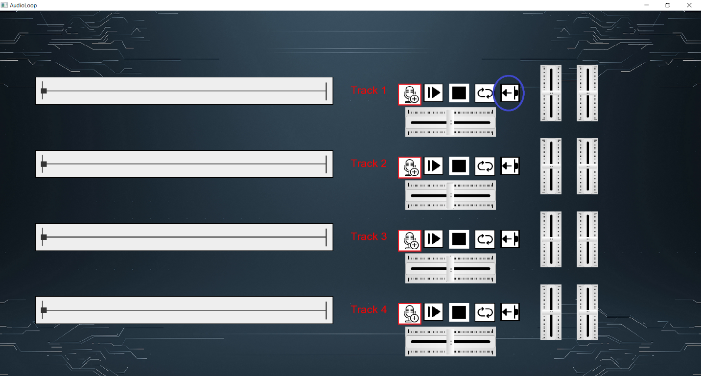

**Figure 6 – The Reverse Button**

## Record Button:

The record will allow the recording of audio. Selecting the button will allow the user to record whatever audio’s being played coupled with the microphone device.

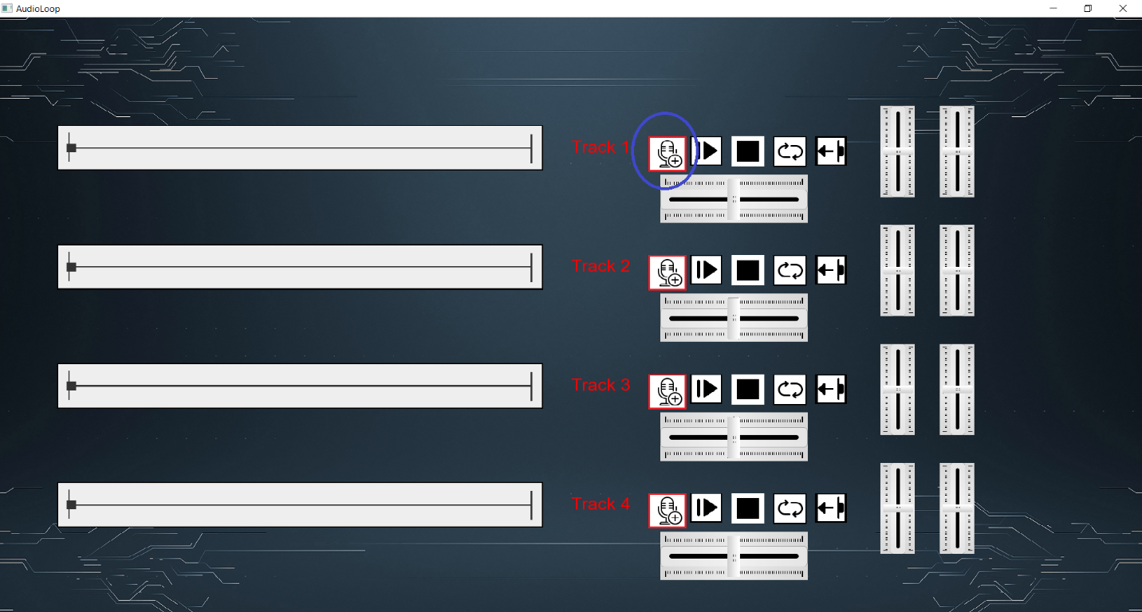

**Figure 7 – The Record Button**

## Volume and Pitch Sliders

The volume slider is circled in Figure 8 and the Pitch slider in Figure 9. Each control their respect values by moving them up to increase the respective audio value and the moving them down to decrease it accordingly.

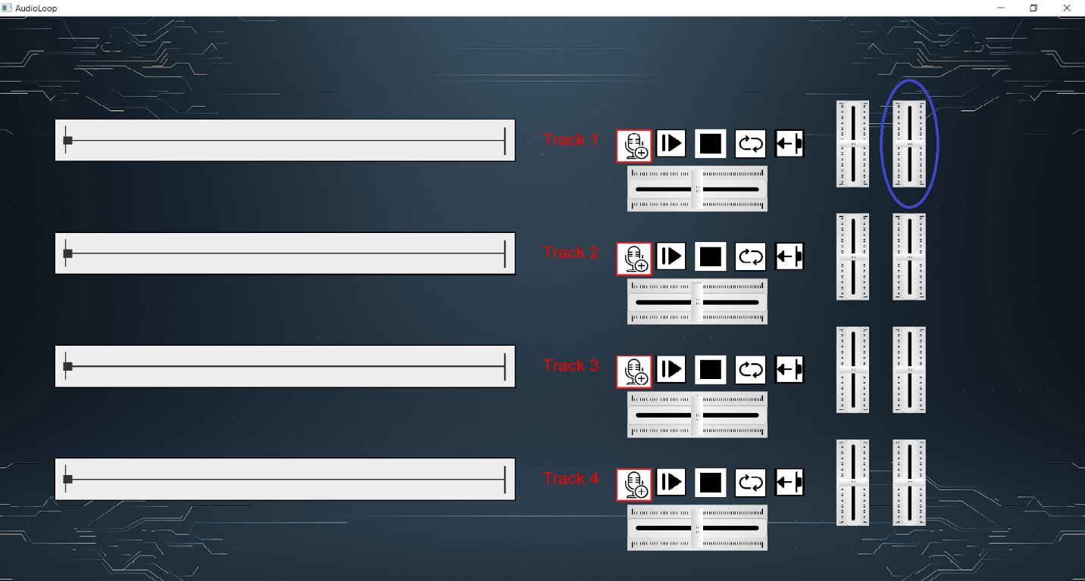

**Figure 8 – The Volume Slider**

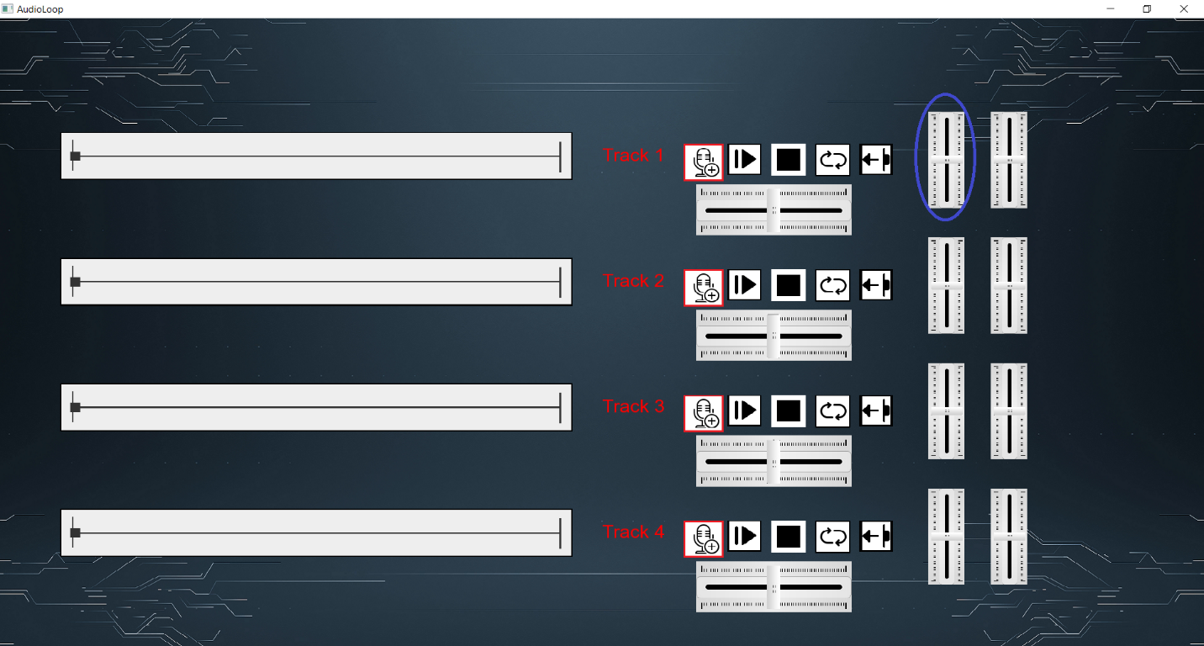

**Figure 9 – The Pitch Slider**

## Pan Slider:

The Pan Slider circled in Figure 10 allows the user to pan through the music. Pushing it the left moves the music backwards and pushing it to the right moves the music forward.

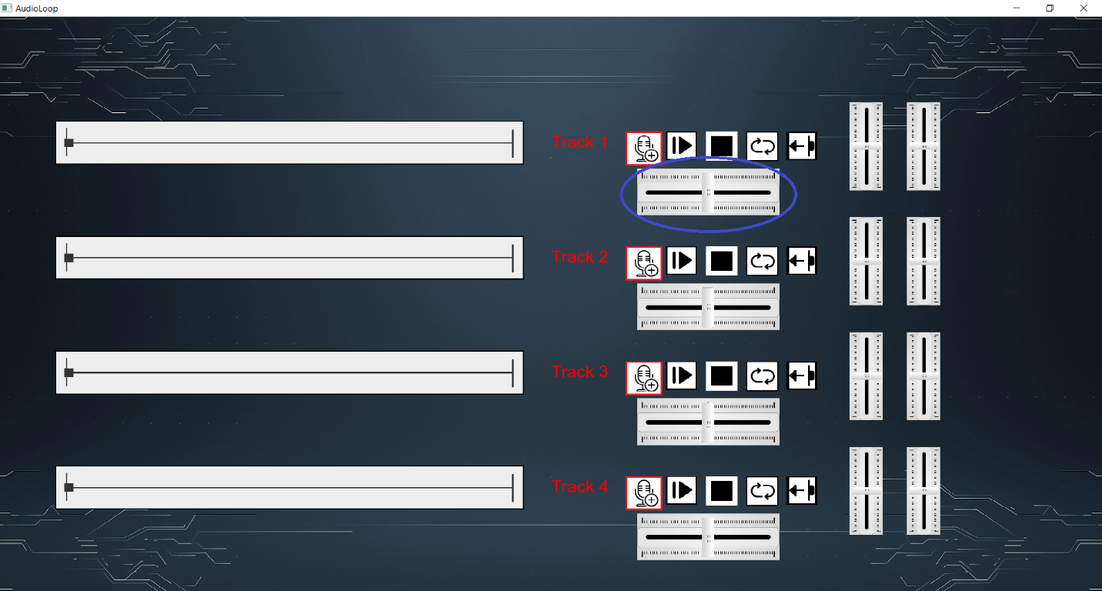

**Figure 10 – The Pan Slider**